Separating a Liquid Solute from a Solution. Distillation
Last lesson we used ___________ to separate a soluble SOLID from a solution.
If the solute is a LIQUID we need to use distillation. This uses both evaporation and condensation.
This system relies on the fact that different liquids have different temperatures that they boil at.
- The mixture is heated till the boiling point of ONLY one liquid is reached. The thermometer allows the temperature to be monitored.
- The gas that has been produced rises up and moves into the central tube of the condenser. The condenser has a water jacket with cool water flowing through it. This cools the gas back to liquid.
- This liquid pours into a collecting beaker.
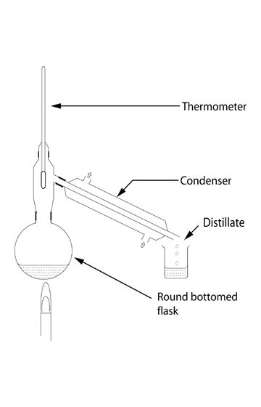
We call the liquid in the collecting beaker the DISTILLATE.
Question. Bob dissolves 10 ml of alcohol in 100ml of water. Later Bob wants to separate the alcohol and water. Alcohol boils at just over 80 degrees Celsius. Water boils at 100 degrees Celsius. A mixture of water and alcohol is placed in the round bottomed flask of a distillation apparatus and heated.
What is the solute in this solution?
What is the solvent in this solution?
What temperature should the mixture be heated to?

What will the distillate be?

What will be left in the starting round bottomed flask?

How will Bob monitor the temperature?

